

**Australian Auto**

**-**

**Sport Alliance Pty Ltd**

ABN: 12 117 743 423

Phone: (03) 5721 7800

PO Box 483, Wangaratta VIC 3677

Website: www.aasa.com.au

Email: info@aasa.com.au

**Bulletin**

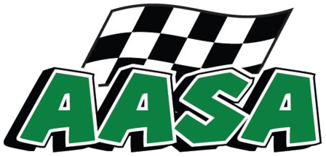

**Reference: UEvent Updates**

**EEEEv**

**Event U**

**Effective Date**

:

26 November 2024

Permit Number AASA221124-101514

E

Item 1: Driving Behaviour.

Due to the Driving behaviour of some of the Competitors in the Transportation sections I have decided to introduce a Yellow Card System.

If you or any of your Team are deemed by the Clerk Of The Course to have driven in a non-safe or non-Law Abiding manner you maybe stood down from the Event for as many Stages of the Event as the Clerk Of The Course deems appropriate. There could be other Penalties that maybe issued in conjunction for the same offences. The confirmation of your Penalty will be sent to your vehicles Rallysafe unit.

Item 2: Rallysafe.

If you have an incident during a Stage and your vehicle is in a dangerous position or impeding on the Course in any way, please push the OK screen and then please put the unit back to the Hazard Screen to warn the following competitors that you are still a Hazard.

Thank you.

**

**AUTHORISED BY Wayne Barnard (Barny) Clerk Of The Course. AASA OLA11257-TL**

:

Australian Auto-Sport Alliance Pty Ltd

:

Up Dated Event Details.